Bash script -2
1️⃣ Check if a directory is available or not
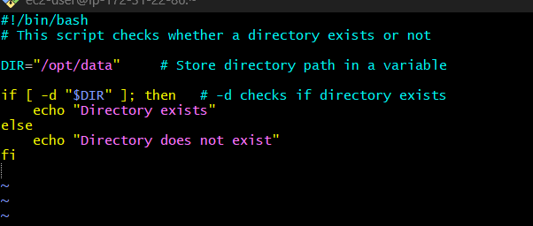
-d → checks if directory exists
🔹 Quotes protect paths with spaces

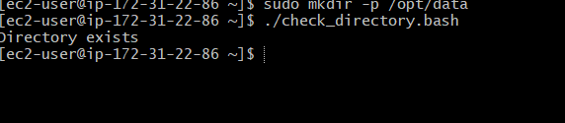

Explanation:
This script checks whether a given directory exists on the system.
It uses the -d test operator, which returns true if the path exists and is a directory.
This is commonly used before performing operations like backup, copy, or delete to avoid errors.

2️⃣Create multiple files
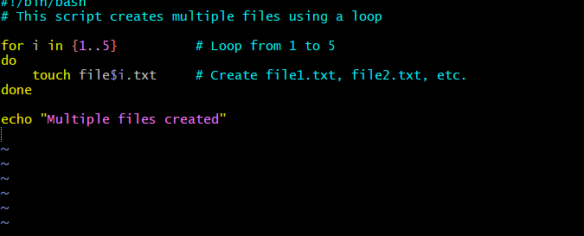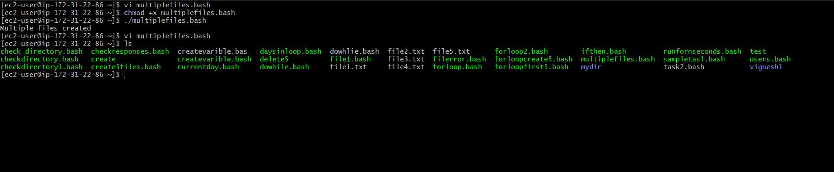
Explanation:
This script creates multiple files in one go using a loop.
The for loop runs multiple times and the touch command creates empty files.
This is useful for testing, automation, and creating dummy files quickly

3️⃣ Take backup of a directory

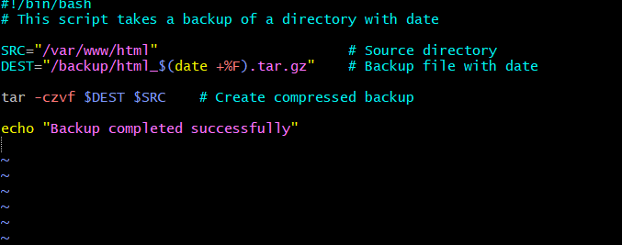
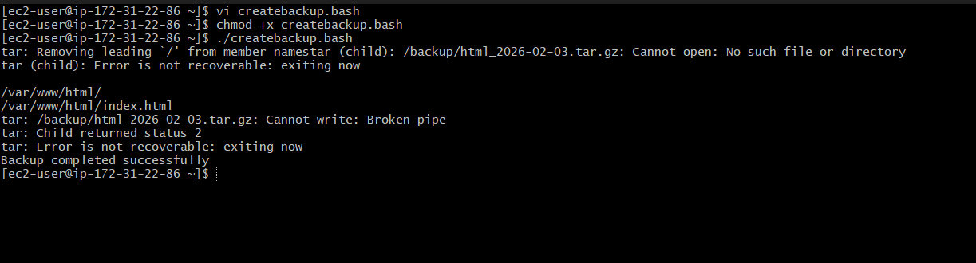

Explanation:
This script creates a compressed backup of a directory using the tar command.
The backup file name includes the current date, which helps maintain daily or versioned backups.
Such scripts are widely used in servers to protect important application and log data.

4️⃣ Install Nginx on EC2 (Amazon Linux)

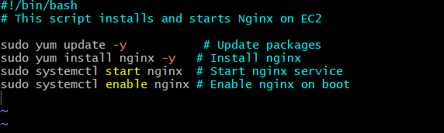

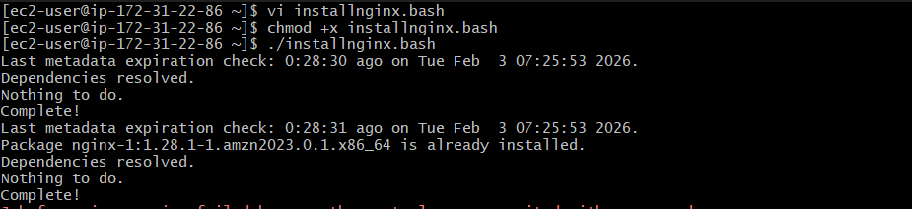
Explanation:
This script installs the Nginx web server on an EC2 instance.
It updates the system packages, installs Nginx, starts the service, and enables it to start automatically on reboot.
This is commonly used during server provisioning and automation.

5️⃣ Install Apache Tomcat on EC2
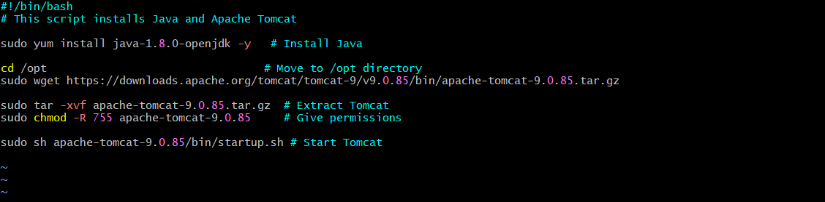
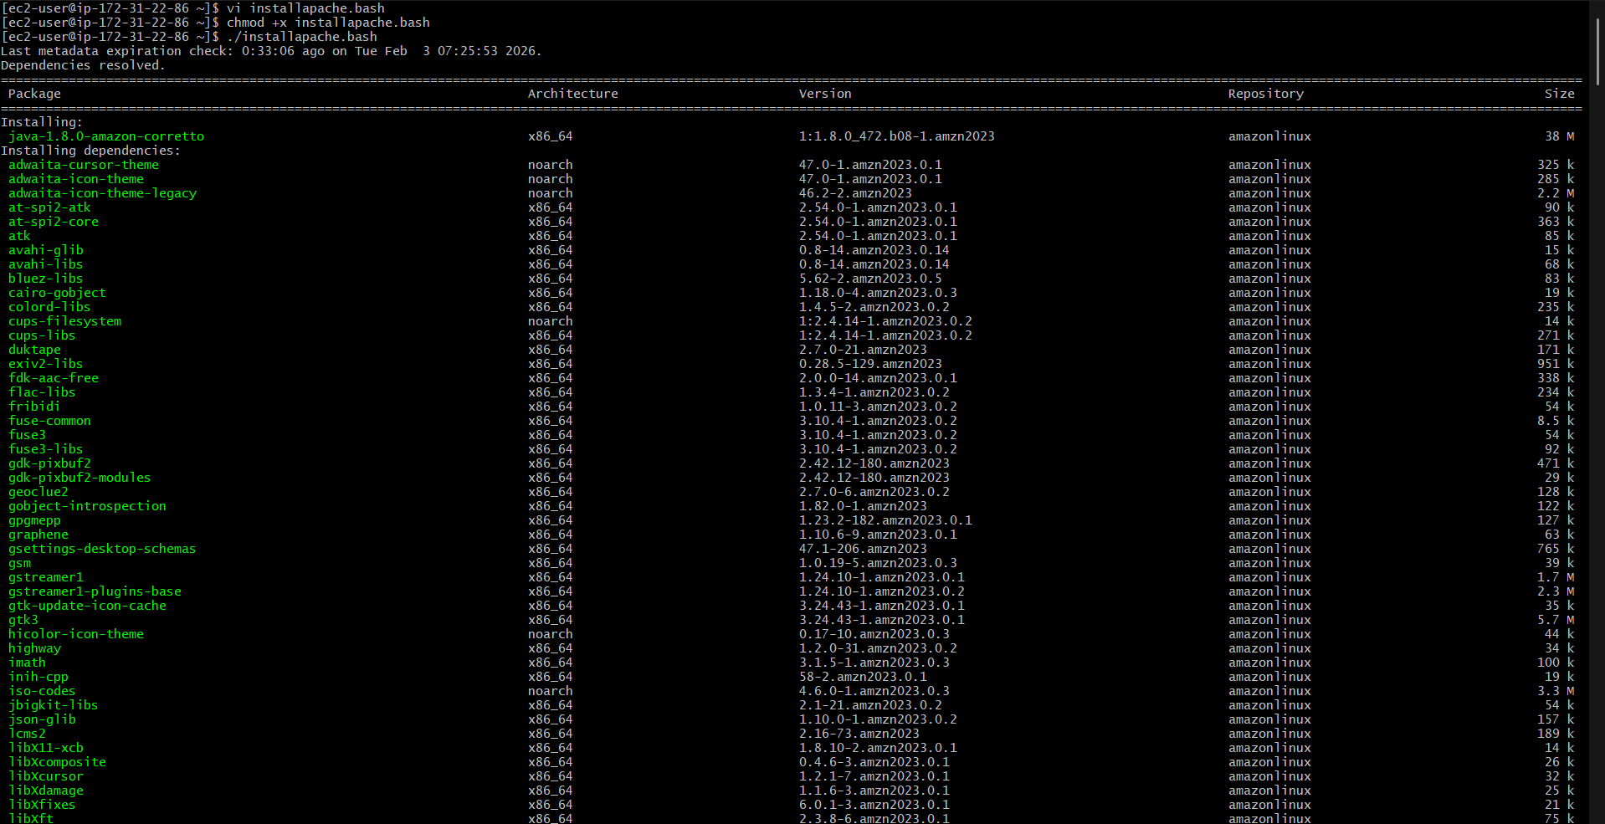
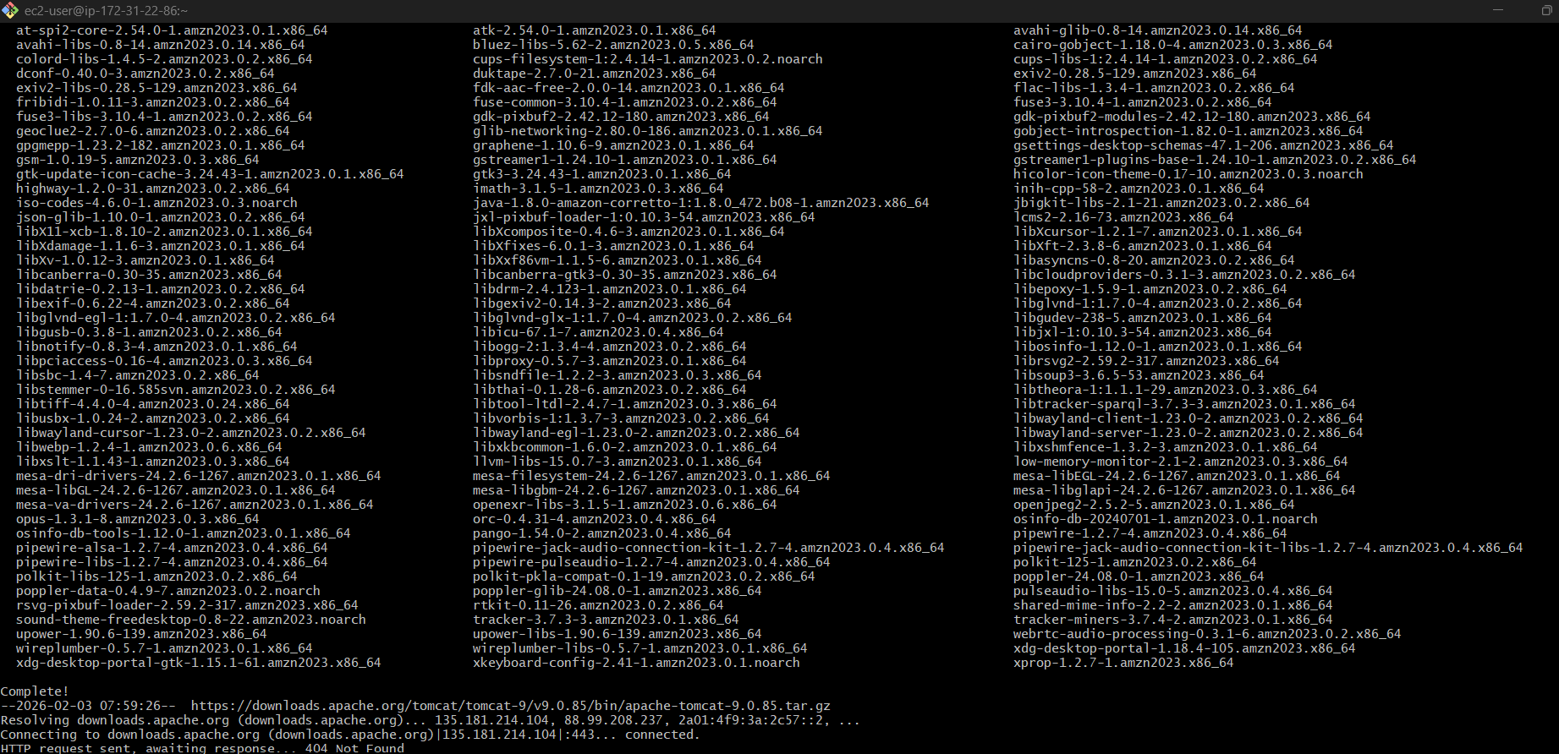

Explanation:
This script installs Java (required for Tomcat) and then downloads and installs Apache Tomcat.
After extraction, required permissions are applied and the Tomcat service is started.
Tomcat is mainly used to host Java-based web applications.

6️⃣ Check Nginx service, start if not running

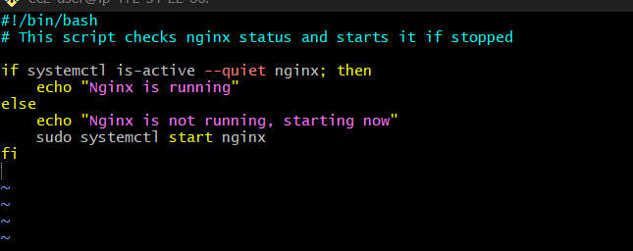
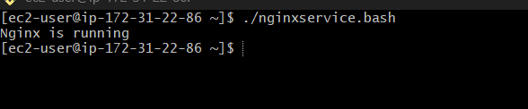
Explanation:
This script checks the current status of the Nginx service using systemctl.
If the service is not running, the script automatically starts it.
Such scripts are used in monitoring and self-healing systems.

7️⃣ Calculator script

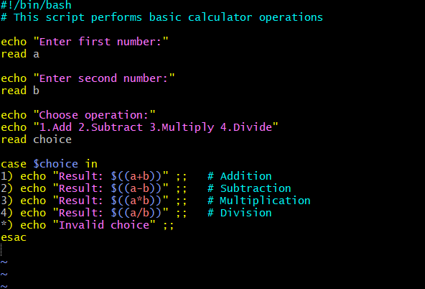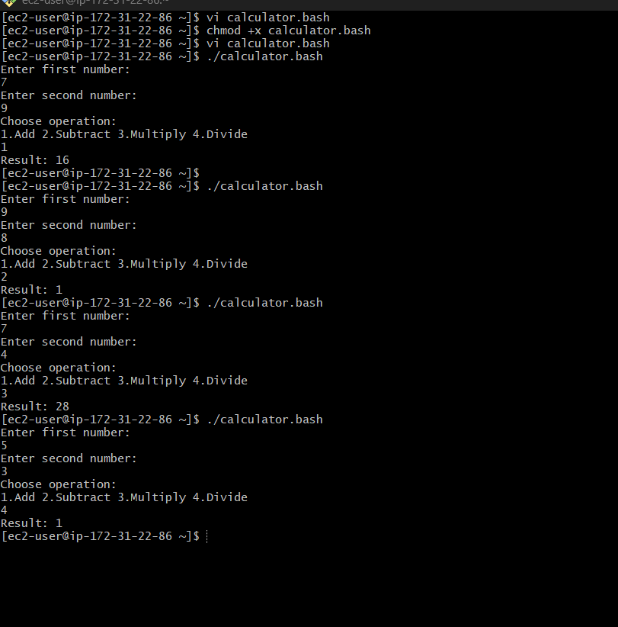
Explanation:
This script performs basic arithmetic operations like addition, subtraction, multiplication, and division.
It uses user input and a case statement to choose the operation.
This example helps beginners understand input handling, conditionals, and arithmetic in Bash.

8️⃣ Check if a directory exists, if not create it

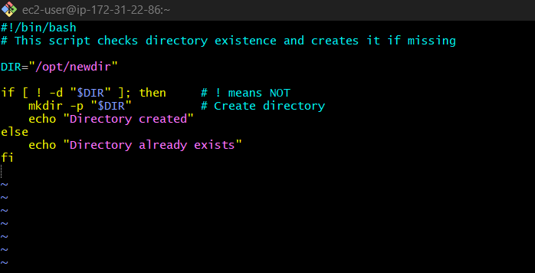
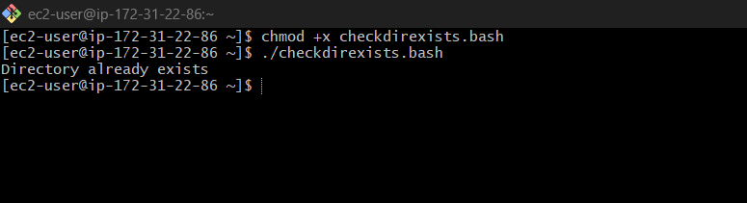

Explanation:
This script checks whether a directory exists.
If the directory is missing, it creates the directory using mkdir -p.
This is commonly used before copying files, storing logs, or taking backups

9️⃣ Delete the last 3 lines of a file

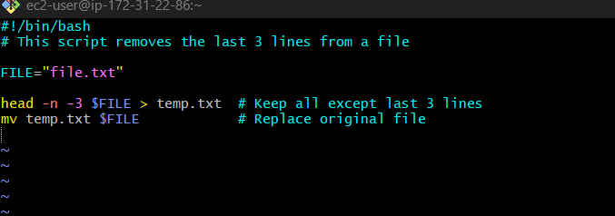
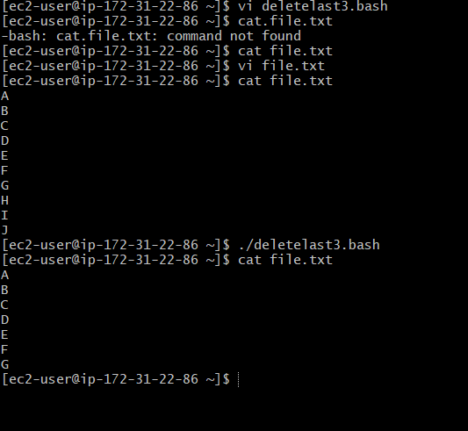
Explanation:
This script removes the last three lines from a file using the head command.
It is useful when cleaning log files or removing unwanted footer data from files.
The file is safely updated by writing to a temporary file first.

🔟 Monitor CPU (>80%) and send email

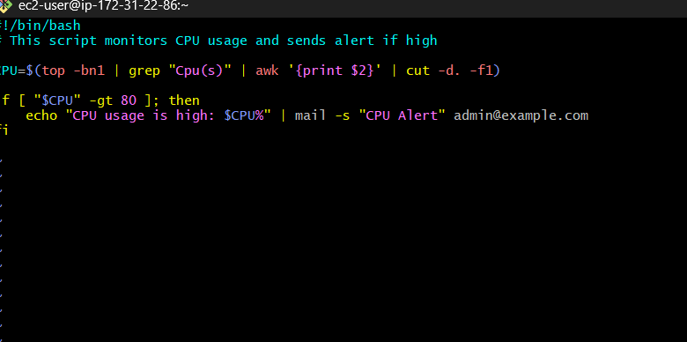
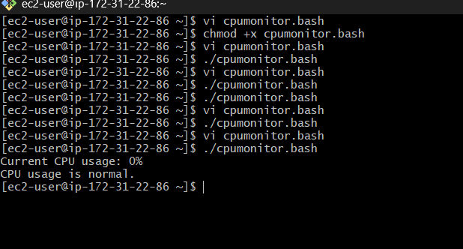

Explanation:
This script monitors the CPU usage of the system.
If CPU usage crosses 80%, it sends an email alert to the administrator.
This is helpful in proactive monitoring to prevent server performance issues.

1️⃣1️⃣ Monitor Disk (>80%) and send email
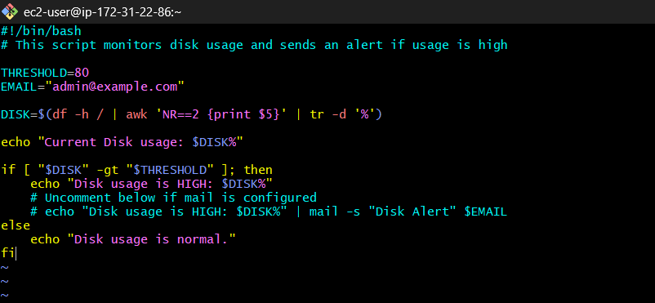
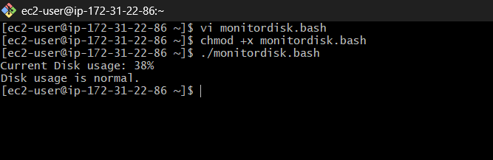
Explanation:
This script checks disk usage of the root filesystem.
If disk usage exceeds 80%, an email notification is sent.
This prevents issues like application crashes due to disk space exhaustion.

1️⃣2️⃣ Monitor Memory (>80%) and send email

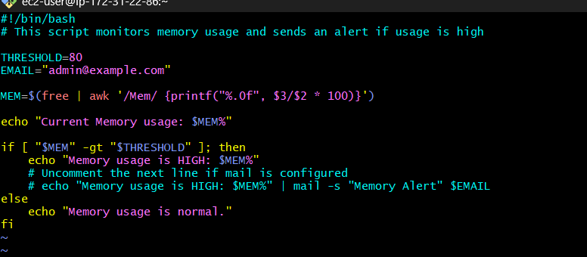
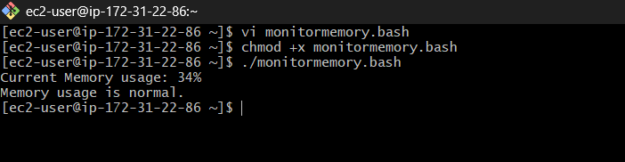

Explanation:
This script monitors memory usage using the free command.
If memory usage crosses the defined threshold, an alert email is sent.
Memory monitoring helps detect leaks and resource-heavy processes.

CRONTAB ENTRIES

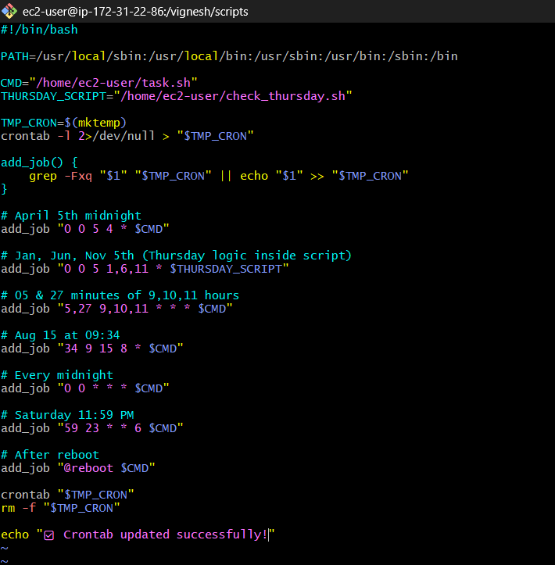
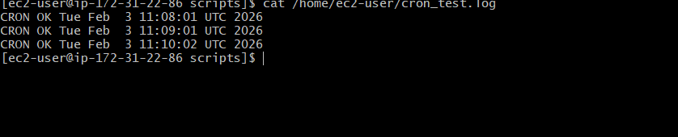
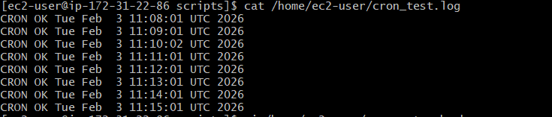

Cron Automation Script – Complete Explanation
This document explains the cron automation shell script step by step, including cron syntax, logic, best practices, and execution proof. The script safely manages multiple cron jobs without duplicating existing entries.

1. Purpose of the Script
The script:
- Automatically manages multiple cron jobs
- Preserves existing crontab entries
- Avoids duplicate cron jobs
- Uses absolute paths to avoid cron PATH issues
- Handles complex scheduling logic cleanly
This is a production-ready cron management approach.

2. Script Header & Environment Setup
#!/bin/bash
- Ensures the script runs using Bash shell.
- Prevents execution issues when run from cron or manually.
PATH=/usr/local/sbin:/usr/local/bin:/usr/sbin:/usr/bin:/sbin:/bin
- Explicitly sets PATH because cron runs with a minimal environment.
- Guarantees availability of commands like crontab, grep, mktemp.

3. Script Variables
CMD="/home/ec2-user/task.sh"
THURSDAY_SCRIPT="/home/ec2-user/check_thursday.sh"
- CMD → Main task script executed by most cron jobs
- THURSDAY_SCRIPT → Script that internally checks whether the day is Thursday
This keeps cron expressions simple and logic inside scripts.

4. Temporary Crontab File
TMP_CRON=$(mktemp)
- Creates a secure temporary file in /tmp
- Used to safely build the updated crontab

5. Preserve Existing Cron Jobs
crontab -l 2>/dev/null > "$TMP_CRON"
- crontab -l → lists current cron jobs
- 2>/dev/null → suppresses error if no crontab exists
- Output stored in temporary file
Ensures existing cron jobs are not lost.

6. add_job Function (Duplicate Prevention)
add_job() {
grep -Fxq "$1" "$TMP_CRON" || echo "$1" >> "$TMP_CRON"
}
How it works:
- -F → fixed string (no regex)
- -x → full-line match
- -q → quiet mode
Logic:
- If the cron job already exists → do nothing
- If not → append it
This prevents duplicate cron entries, a common production issue.

7. Cron Jobs Explained
April 5th at Midnight
add_job "0 0 5 4 * $CMD"
Runs once a year on April 5 at 00:00.

January, June, November 5th (Thursday logic inside script)
add_job "0 0 5 1,6,11 * $THURSDAY_SCRIPT"
Runs on:
- Jan 5
- Jun 5
- Nov 5
The script itself checks whether the day is Thursday.

05 & 27 Minutes of 9, 10, 11 AM
add_job "5,27 9,10,11 * * * $CMD"
Runs at:
- 09:05, 09:27
- 10:05, 10:27
- 11:05, 11:27

August 15 at 09:34
add_job "34 9 15 8 * $CMD"
Runs once per year on Aug 15 at 09:34.

Every Midnight
add_job "0 0 * * * $CMD"
Runs daily at 12:00 AM.

Saturday at 11:59 PM
add_job "59 23 * * 6 $CMD"
Runs every Saturday at 23:59.

After System Reboot
add_job "@reboot $CMD"
Runs once after every server reboot.

8. Install Updated Crontab
crontab "$TMP_CRON"
- Replaces the user crontab with the updated version
- Includes both old and new jobs

9. Cleanup
rm -f "$TMP_CRON"
Deletes the temporary file to keep the system clean.

10. Confirmation Message
echo "☑ Crontab updated successfully!"
Indicates script completion (visual confirmation).

11. Execution Proof (Log Output)
CRON OK Tue Feb 3 11:08:01 UTC 2026
CRON OK Tue Feb 3 11:09:01 UTC 2026
CRON OK Tue Feb 3 11:10:02 UTC 2026
CRON OK Tue Feb 3 11:11:01 UTC 2026
This confirms:
- Cron daemon is running
- Jobs are executing on schedule
- Script paths and permissions are correct

